H.T No
Regulations:
A17

Sreenidhi Institute of Science and Technology
(An Autonomous Institution)
Code No: 6W102 Date: 02-Aug-2018 (FN)

M.Tech I-Year I-Semester External Examination, July/Aug - 2018 (Supplementary)
Advanced Finite Element Analysis (CAD/CAM)

Time: 3 Hours Max.Marks:75

Note: a) No additional answer sheets will be provided.
b) All sub-parts of a question must be answered at one place only, otherwise it will not be valued.
c) Missing data can be assumed suitably.

Part - A Max.Marks:25

Answer all QUESTIONS.

1. | What are the various steps involved in finite difference method? | [3M]
2. | Write down the stiffness matrix for beam element. | [3M]
3. | What is the interpolation polynomial for rectangular plate element? | [3M]
4. | Discuss about dynamic equation of motion. | [3M]
5. | Write about formulation of radiation problem in finite element method. | [3M]
6. | Write about stream function formulation of fluid flow. | [2M]
7. | Differentiate between truss and frame element | [2M]
8. | What is the difference between lumped mass matrix consistent mass matrix? | [2M]
9. | Interpret the two dimensional heat transfer equation for triangular element. | [2M]
10. | What is Rayleigh damping? | [2M]
Part – B Max.Marks:50
ANSWER ANY FIVE QUESTIONS. EACH QUESTION CARRIES 10 MARKS.

11. |  | Calculate seven iterations of the power method with scaling to approximate a dominant Eigen vector of the matrix  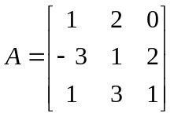  Use x₀ = ( 1,1,1) as initial approximation. | [10M]
12. |  | For the three bar truss shown in below Fig. determine the displacements of node 1 and the stress in element 3  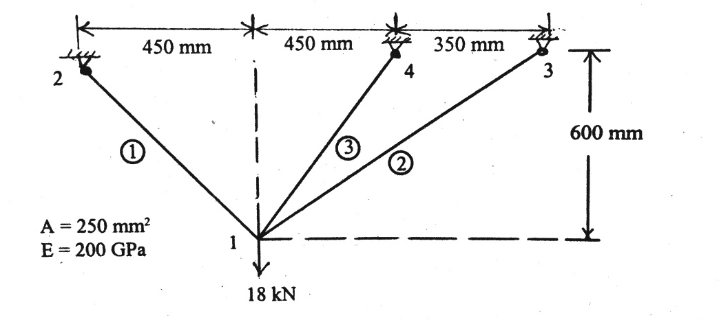 | [10M]
13. |  | Explain the term Mindlin’s C⁰-continuity plate element and briefly explain stiffness matrix formulation for such elements. | [10M]
14. |  | Determine the nodal displacements for the beam shown in below Fig. Take E= 100 GPa, I = 2500 cm⁴  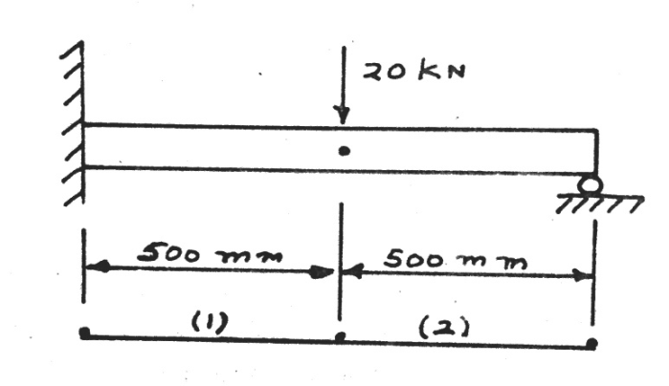 | [10M]
15. |  | Calculate the nodal temperature of an insulated rod shown in below fig when a heat flux of 5 W/cm² is supplied at the left face and choosing the time as ∆t = 10 seconds. Initially the rod is at 0⁰C. Find temperature at 3 time steps.  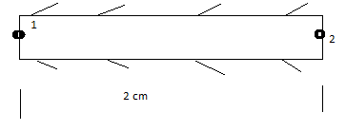 | [10M]
16. |  | Find the potentials at the junctions, the velocities in each pipe and the volumetric flow rate for the smooth pipe of variable cross-section shown in below figure. The potential at the left end is 10 m and that at the right end is 3 m. the permeability coefficient is 1 m/sec.  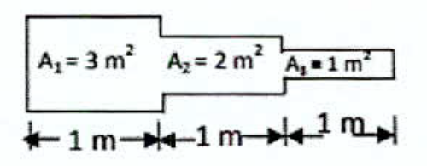 | [10M]
17. |  | Consider a brick wall of thickness 30 cm, k=0.7W/m⁰C. The inner surface is at 28⁰C and the outer surface is exposed to cold air at -15⁰C. The h for outside surface is 40W/m² ⁰C. Determine the steady state temperature distribution within the wall. Use a two element model.  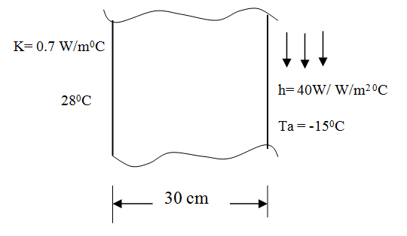 | [10M]

-- 00 -- 00 –

